CE221-L Digital Logic Design Lab



Lab # 10

Submitted by:
- Shayan Rizwan [2024585]
Submitted to: Sir Irfanullah
Semester: 3rd

Faculty of Computer Science and Engineering
GIK Institute of Engineering Sciences and Technology

Task # 1:
Implement a synchronous SR flip-flop in Verilog with positive-edge clock triggering, including Set, Reset, Hold, and Invalid state functionality according to standard SR flip-flop truth table behavior.

Design Source [Code]
`timescale 1ns / 1ps
//////////////////////////////////////////////////////////////////////////////////
// Company:
// Engineer:
//
// Create Date: 12/01/2025 12:02:51 AM
// Design Name:
// Module Name: sr_flipflop
// Project Name:
// Target Devices:
// Tool Versions:
// Description:
// Positive-edge triggered SR flip-flop with synchronous reset.
// Implements classic SR flip-flop behavior with defined reset state.
// Note: S=R=1 remains invalid/undefined per flip-flop fundamentals.
//
// Dependencies:
//
// Revision:
// Revision 0.01 - File Created
// Additional Comments:
//
//////////////////////////////////////////////////////////////////////////////////

module sr_flipflop(
input wire S,
input wire R,
input wire CLK,
output reg Q,
output reg Qbar
);

initial
begin
Q = 1'b0;
Qbar = 1'b1;
end
always @(posedge CLK) begin
case ({S, R})
2'b00: begin // No change state: outputs retain previous values
Q <= Q;
Qbar <= Qbar;
end

2'b01: begin
Q <= 1'b0; // Reset operation: Q cleared to 0, Qbar set to 1
Qbar <= 1'b1;
end

2'b10: begin
Q <= 1'b1; // Set operation: Q set to 1, Qbar cleared to 0
Qbar <= 1'b0;
end

2'b11: begin
Q <= 1'bx; // Invalid condition: both set and reset asserted
Qbar <= 1'bx;
end

default: begin
// Catch-all for undefined states (good practice)
Q <= 1'bx;
Qbar <= 1'bx;
end

endcase
end

endmodule

Test Bench [Code]
`timescale 1ns / 1ps
//////////////////////////////////////////////////////////////////////////////////
// Company:
// Engineer:
//
// Create Date: 12/01/2025 12:02:51 AM
// Design Name:
// Module Name: sr_flipflop_tb
// Project Name:
// Target Devices:
// Tool Versions:
// Description: Testbench for SR Flipflop verification
//
// Dependencies: sr_flipflop.v
//
// Revision:
// Revision 0.01 - File Created
// Additional Comments:
//
//////////////////////////////////////////////////////////////////////////////////

module sr_flipflop_tb;

// Testbench signals
reg S, R, CLK; // inputs are defined as reg (in the testbench)
wire Q, Qbar; // outputs are defined as wire (in the testbench)

// Instantiate the Unit Under Test (UUT)
sr_flipflop uut (
.S(S),
.R(R),
.CLK(CLK),
.Q(Q),
.Qbar(Qbar)
);

// Clock generation (100MHz clock - 10ns period)
initial begin
CLK = 0;
forever #5 CLK = ~CLK; // 10ns period clock
end

// Test sequence
initial begin
// Initialize inputs
S = 0;
R = 0;

// Wait for global reset
#10;

// Test case 1: No change (S=0, R=0)
S = 0; R = 0;
#10;

// Test case 2: Reset (S=0, R=1)
S = 0; R = 1;
#10;

// Test case 3: Set (S=1, R=0)
S = 1; R = 0;
#10;

// Test case 4: Invalid state (S=1, R=1)
S = 1; R = 1;
#10;

// Test case 5: Return to reset state
S = 0; R = 1;
#10;

// Test case 6: Return to set state
S = 1; R = 0;
#10;

// End simulation
$display("SR Flipflop testbench completed");
$finish; // DO NOT FORGET THE SEMI COLON AT THE END OF $finish;
end
endmodule

Output:
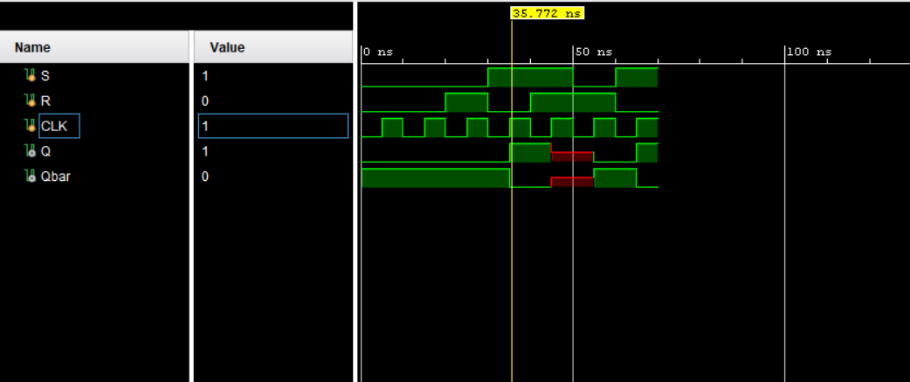

Task # 2:
Implement a synchronous JK flip-flop in Verilog with positive-edge clock triggering, including Hold, Reset, Set, and Toggle functionality according to standard JK flip-flop truth table behavior, eliminating the invalid state present in SR flip-flops.

Design Source [Code]
`timescale 1ns / 1ps
//////////////////////////////////////////////////////////////////////////////////
// Company:
// Engineer:
//
// Create Date: 12/01/2025 12:02:51 AM
// Design Name: JK Flip-Flop
// Module Name: jk_flipflop
// Project Name:
// Target Devices:
// Tool Versions:
// Description: Positive-edge triggered JK flip-flop with synchronous operation
//
// Dependencies:
//
// Revision:
// Revision 0.01 - File Created
// Additional Comments:
// JK flip-flop eliminates invalid state of SR flip-flop using toggle functionality
//
//////////////////////////////////////////////////////////////////////////////////

module jk_flipflop(
output reg Q, // Main output
output reg Qbar, // Complementary output
input wire CLK, // Positive-edge trigger clock
input wire J, // Set condition input
input wire K // Reset condition input
);

// Sequential logic with positive-edge trigger
always @(posedge CLK) begin
case({J, K})
2'b00: Q <= Q; // No change: retain previous state
2'b01: Q <= 1'b0; // Reset: clear output to 0
2'b10: Q <= 1'b1; // Set: set output to 1
2'b11: Q <= ~Q; // Toggle: invert current state
endcase

Qbar <= ~Q; // Generate complementary output
// This is another syntax to define the sequential logic inside the 'always' block.
end

endmodule

Test Bench [Code]
`timescale 1ns / 1ps
//////////////////////////////////////////////////////////////////////////////////
// Company:
// Engineer:
//
// Create Date: 12/01/2025 12:02:51 AM
// Design Name: JK Flip-Flop Testbench
// Module Name: jk_flipflop_tb
// Project Name:
// Target Devices:
// Tool Versions:
// Description: Comprehensive testbench for JK flip-flop verification
//
// Dependencies: jk_flipflop.v
//
// Revision:
// Revision 0.01 - File Created
// Additional Comments:
// Tests all JK input combinations including toggle functionality
//
//////////////////////////////////////////////////////////////////////////////////

module jk_flipflop_tb;

// Inputs (test stimuli)
reg CLK;
reg J;
reg K;

// Outputs (monitor these)
wire Q;
wire Qbar;

// Instantiate Unit Under Test (UUT)
jk_flipflop uut (
.Q(Q),
.Qbar(Qbar),
.CLK(CLK),
.J(J),
.K(K)
);

// Clock generation: 50MHz clock (20ns period)
initial begin
CLK = 0;
forever #10 CLK = ~CLK; // 20ns period = 50MHz
end

// Test sequence
initial begin
// Initialize all inputs
CLK = 0;
J = 0;
K = 0;

// Wait for initial stabilization
#20;

// Test Case 1: No change (J=0, K=0)
J = 0; K = 0;
#100;

// Test Case 2: Reset (J=0, K=1)
J = 0; K = 1;
#100;

// Test Case 3: Set (J=1, K=0)
J = 1; K = 0;
#100;

// Test Case 4: Toggle (J=1, K=1) - Critical test case
J = 1; K = 1;
#100;

// Test Case 5: Verify toggle continues
J = 1; K = 1;
#100;

// End simulation
$display("JK Flip-Flop test completed successfully");
$finish;
end

endmodule

Output
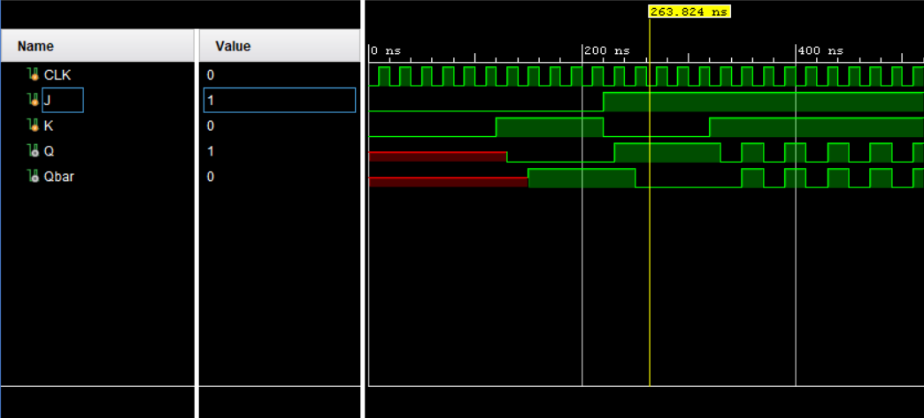

Task # 3:
Implement a synchronous T flip-flop in Verilog with positive-edge clock triggering that toggles its output state when enabled and retains its current state when disabled, including proper reset functionality.

Design Source [Code]
`timescale 1ns / 1ps
//////////////////////////////////////////////////////////////////////////////////
// Company:
// Engineer:
//
// Create Date: 12/01/2025 12:02:51 AM
// Design Name: T Flip-Flop Derived from JK Flip-Flop
// Module Name: t_flipflop
// Project Name:
// Target Devices:
// Tool Versions:
// Description:
// T Flip-Flop implementation by connecting J and K inputs together.
// This creates a JK flip-flop where J=K=T, resulting in:
// - T=0: J=K=0 -> Hold state (no change)
// - T=1: J=K=1 -> Toggle state (invert output)
//
// Dependencies:
//
// Revision:
// Revision 0.01 - File Created
// Additional Comments:
// Fundamental relationship: T Flip-Flop = JK Flip-Flop with J=K=T
//
//////////////////////////////////////////////////////////////////////////////////

module t_flipflop(
output reg Q, // Flip-flop output
input wire T, // Toggle enable input
input wire CLK, // Positive-edge trigger clock
input wire RST // Asynchronous active-high reset
);

// Sequential logic with asynchronous reset
always @(posedge CLK or posedge RST) begin
if (RST) // Same as: if (RST == 1'b1)
Q <= 1'b0; // Reset condition (highest priority)
else begin
// T Flip-Flop behavior derived from JK Flip-Flop truth table:
// When J=K=T, the JK behavior becomes:
case(T)
1'b0: Q <= Q; // T=0: J=0,K=0 -> Hold state (JK: no change)
1'b1: Q <= ~Q; // T=1: J=1,K=1 -> Toggle state (JK: toggle)
endcase

/*
JK Flip-Flop Truth Table (for reference):
J K | Q(t+1)
---------------
0 0 | Q(t) // Hold
0 1 | 0 // Reset
1 0 | 1 // Set
1 1 | ~Q(t) // Toggle

When we set J=K=T:
T | J K | Q(t+1) | T Flip-Flop Behavior
--------------------------------------------
0 | 0 0 | Q(t) | Hold (no change)
1 | 1 1 | ~Q(t) | Toggle (invert)
*/
end
end

endmodule

Test Bench [Code]
`timescale 1ns / 1ps
//////////////////////////////////////////////////////////////////////////////////
// Company:
// Engineer:
//
// Create Date: 12/01/2025 12:02:51 AM
// Design Name: T Flip-Flop Testbench
// Module Name: t_flipflop_tb
// Project Name:
// Target Devices:
// Tool Versions:
// Description: Comprehensive testbench for T flip-flop verification
// Tests reset functionality, hold state, and toggle operation
//
// Dependencies: t_flipflop.v
//
// Revision:
// Revision 0.01 - File Created
// Additional Comments:
// Verifies asynchronous reset priority and toggle behavior
//
//////////////////////////////////////////////////////////////////////////////////

module t_flipflop_tb;

// Inputs (test stimuli)
reg T;
reg CLK;
reg RST;

// Outputs (monitor these)
wire Q;

// Instantiate Unit Under Test (UUT)
t_flipflop uut (
.Q(Q),
.T(T),
.CLK(CLK),
.RST(RST)
);

// Clock generation: 50MHz clock (20ns period)
initial begin
CLK = 0;
forever #10 CLK = ~CLK; // 20ns period = 50MHz
end

// Test sequence
initial begin
// Initialize all inputs
CLK = 0;
RST = 1; // Assert reset initially
T = 0;

// Test Case 1: Initial reset condition
#15; // Wait past first clock edge

// Test Case 2: Release reset, T=0 (hold state)
RST = 0;
T = 0;
#40;

// Test Case 3: T=1 (toggle mode - multiple cycles)
T = 1;
#80; // Allow multiple toggle cycles

// Test Case 4: T=0 (hold current state)
T = 0;
#40;

// Test Case 5: T=1 (resume toggling)
T = 1;
#40;

// Test Case 6: Asynchronous reset assertion during operation
RST = 1;
#20;

// Test Case 7: Continue operation after reset release
RST = 0;
T = 1;
#60;

// End simulation
$display("T Flip-Flop test completed successfully");
$finish;
end

endmodule

Output
